**Normal distribution & Functions of Random Variables**

1. The time required for servicing transmissions is normally distributed with μ = 45 minutes and σ = 8 minutes. The service manager plans to have work begin on the transmission of a customer’s car 10 minutes after the car is dropped off and the customer is told that the car will be ready within 1 hour from drop-off. What is the probability that the service manager cannot meet his commitment ?
2. 0.3875
3. 0.2676
4. 0.5
5. 0.6987
6. The current age (in years) of 400 clerical employees at an insurance claims processing center is normally distributed with Mean μ = 38 and Standard Deviation σ = 6. For each statement below, please specify True/False. If False, briefly explain why.
7. More employees at the processing center are older than 44 than between 38 and 44.
8. A training program for employees under the age of 30 at the center would

be expected to attract about 36 employees.

1. If X1 ~ N(μ, σ2) and X2 ~ N(μ, σ2) are normal random variables, then what is the difference between 2 X1 and X1 + X2? Discuss both their distributions and parameters.

Both Random variables have the value as follows :

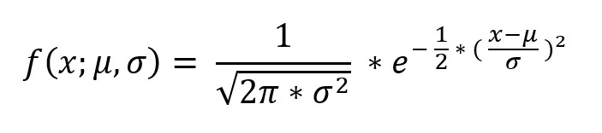

Both of them follow the same normal distributions and have the same value so 2X1 = X1 + X2.

μ is the mean value and σ2 is the standard deviation.

1. Let X ~ N(100, 202). Find two values a and b, symmetric about the mean, such that the probability of the random variable taking a value between them is 0.99.
2. 90.5, 105.9
3. 80.2, 119.8
4. 22, 78
5. 48.5, 151.5
6. 90.1, 109.9

Let the two values be a and b.These values are symmetric about the mean.

a + x = 100 and b - x = 100

a = 100 - x and b = 100 + x

Let the random value be X.

The probability that the random variable takes a value between them is 0.99

P(a<X<b) = 0.99

1. Consider a company that has two different divisions. The annual profits from the two divisions are independent and have distributions Profit1 ~ N(5, 32) and Profit2 ~ N(7, 42) respectively. Both the profits are in $ Million. Answer the following questions about the total profit of the company in Rupees. Assume that $1 = Rs. 45.
2. Specify a Rupee range (centered on the mean) such that it contains 95% probability for the annual profit of the company.
3. Specify the 5th percentile of profit (in Rupees) for the company.
4. Which of the two divisions has a larger probability of making a loss in a given year?

For Profit1 : Mean = 5 , SD = 32 = 9

For Profit2 : Mean = 7 , SD = 42 = 16

1. Confidence Level = 95% = 0.95

Z score = 1.96

Range = x̄ ± z* σ / (√n) = 5 ± 1.96*9/√100 = 5 ± 1.764 = [3.236,6.764]

Range in Rupees = [145.62 , 304.38]

1. Percentile = n *(upper limit-lower limit)/100

= 5*(304.38-145.62)/100

= 7.938

1. The second division has a larger probability of making a loss because the standard deviation is higher at 16.